Colonial Period – Articles of Confederation Exam
100 point exam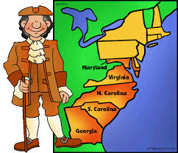
50 Multiple Choice Questions

Topics to be familiar with:
- Characteristics of Jamestown/Plymouth
- How democratic was colonial America? (Mayflower Compact, House of Burgesses, mercantilism, salutary neglect)
- Causes and Effects of French/Indian War (Albany Plan of Union, Proclamation of 1763)
- New Colonial Policy
- Colonist reactions to New Colonial Policy
- Declaration of Independence
- “Common Sense” –Thomas Paine
- How were the colonists able to defeat the British during the American Revolution?
- Articles of Confederation –why did this type of government develop? Characteristics/weaknesses—why did the Articles fail?

