US State/Colonial Quest 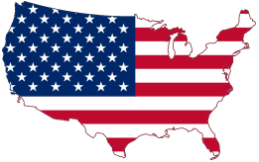
60 Points—Thursday Sept. 17

Part I: 50 points
*Map Identification-25 states
****Bonus: Correctly identify the 25 capitals of given states on exam for 10 points and class recognition (ALL OR NOTHING!!!)****

Part II: Short answer (10 points)
You will be given 3 short response questions; you will respond to 2 questions
- Reasons for English settlement in North America
- Settlement of Jamestown
- Settlement of Plymouth
- European government influence on the British colonies
- British colonial policy (salutary neglect/mercantilism)
- French/Indian War

