Mrs.Aguado 25 points
Due Date: Tuesday Sept. 30

Create Your Own Civilization Project

After you have created the outline for your civilization, your mission is to create a travel brochure that will entice others to come and live in your civilization.
Your brochure should include the following:
    - The information from your outline
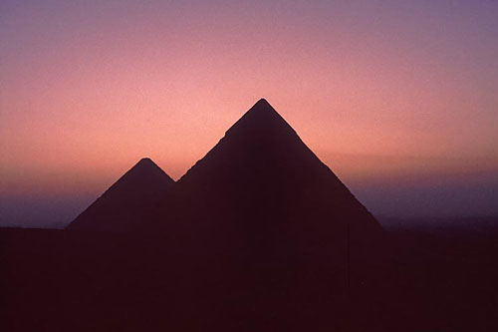
    - Pictures that represent the values and beliefs of your civilization. (Hand drawings will be accepted). Incorporate at least 4 images throughout your brochure.
    - A catchy slogan to get the attention of the reader.
    - At least a three sided brochure.
    - Be creative :)

*Remember you want people to visit your civilization, but you also want it to survive.*

**You will be working in groups for this project. You may choose who you work with (no less than 3, no more than 4 people per group)**

